**NATIONAL INSTITUTE OF TECHNOLOGY**

**TIRUCHIRAPPALLI**



Department of Computer Application

***COLLEGE MANAGEMENT SYSTEM***

**Project Work**

Submitted By :

**SANJAY KUMAR**

**205119091**

Under the Guidance of

**Dr. U. Vignesh**

**INDEX**

|  |  |  |  |
| --- | --- | --- | --- |
| **S.No** | **CONTENT** | **PAGE No.** | **REMARK** |
| **1.** | Introduction | 3 |  |
| **1.a.** | Abstract | 3 |  |
| **2.** | Analysis | 4 |  |
| **4.** | Technology | 6 |  |
| **5.** | Hardware & software requirement | 9 |  |
| **6.** | System Portal Images | 11 |  |
| **7.** | DATABASE Images | 23 |  |
| **8.** | CONCLUSION | 26 |  |

1. **INTRODUCTION**

The main objective of developing the current project entitled “COLLEGE MANAGEMENT SYSTEM” is to build a system that can help students and teachers maintain their information without the use of paperwork and manpower.

Time and man power can be more effectively utilized and online information can be easily available to the user.

Every user such as student, staff and administration can able to see the information of each student through online from anywhere and anytime.

**1.a ABSTRACT:**

The College Management System is a web application which allows us to access the total information about the college, staff and students. In this system, we can get the latest information about the students and staff. This system will maintain information about teachers and students and that information can be easily updated and deleted. The system will be maintained by the administrator and he can access both students and teachers department. Since the data stored in computer using DBMS , we can retrieve the record of any student and teacher whenever we require it.

# ANALYSIS:

**STUDY OF THE PROBLEM**

The COLLEGE MANAGEMENT SYSTEM is to manage the data of students and teachers effectively. The idea behind this system is that students and teachers can view their information from anywhere and anytime. The information can be updated and deleted easily without use of paperwork. Because of this system the use of paper and ink will be reduced. The database will maintain the student and teachers’ details.

**Admin role**

The ADMIN can sign-up and login to the System. THE ADMIN can view, update and delete the students and teachers’ information. ADMIN will be able to make change in database.

**TEACHER ROLE**

Teachers can view their information anytime and anywhere online. Teacher can’t make any changes to the database.

**STUDENT ROLE**

Student can view their information anytime and anywhere online. Student can’t make any changes to the database.

**PROJECT SCOPE**

This project deals with the various functioning in College management process. The main idea is to implement a proper process to system. In our existing system contains a many operations like updating and deleting the information of students and teacher. All these activity takeout manually by administrator.

In our model, it deals with the Operations in system. For example, when students fill the registration form the record is stored in the database. And display the details of student is perform by retrieving information from database table.

1. **Technology:**

**Front End: HTML, CSS, JavaScript**

## HTML & CSS

HTML (The Hypertext Markup Language) and CSS (Cascading Style Sheets) are two of the core technologies for building web pages. HTML provides the structure of the page, CSS the (visual and aural ) layout , for a variety of devices. Along with Graphics and scripting, HTML and CSS are the basis of building Web pages and Web Applications.

## JavaScript

JavaScript is a dynamic computer programming language. It is lightweight and most commonly used as a part of web pages, whose implementations allow client-side script to interact with the user and make dynamic pages. It is an interpreted programming language with object-oriented capabilities.

**Back End: MySQL, PHP**.

## PHP

## PHP (recursive acronym for PHP: Hyper text Preprocessor) Is a widely used open source general purpose scripting language that is especially suited for web development and can be embedded into HTML.

## MYSQL

## MySQL is a fast, easy-to-use RDBMS being used for many small and big businesses. MySQL is developed, marketed and supported by MySQL AB, which is a Swedish company. MySQL is becoming so popular because of many good reasons –

## • MySQL is released under an open-source license. So, you have nothing to pay to use it.

## • MySQL is a very powerful program in its own right. It handles a large subset of the functionality of the most expensive and powerful database packages.

## • MySQL uses a standard form of the well-known SQL data language.

## • MySQL works on many operating systems and with many languages including PHP, PERL, C, C++, JAVA, etc. • MySQL works very quickly and works well even with large data sets.

## • MySQL is very friendly to PHP, the most appreciated language for web development.

## • MySQL supports large databases, up to 50 million rows or more in a table. The default file size limit for a table is 4GB, but you can increase this (if your operating system can handle it) to a theoretical limit of 8 million terabytes (TB).

• MySQL is customizable. The open-source GPL license allows programmers to modify the MySQL software to fit their own specific environments

**4. Hardware And Software Requirement:**

**Hardware Configuration**.

* Terminals: These are simply the desktops where the GUI will be running.
* Processor Pentium –IV and above
* RAM 128 MD SD EAM
* Monitor 800* 600 resolution
* Hard disk 10 GB
* Floppy drive 1.44 MB
* CD drive LG 52X
* Key board Standard 102 keys
* Mouse 3 buttons, scroll able

## ****Software Requirements****

* Operating system -Windows 10
* Coding Language - PHP
* Front end (GUI) - HTML and CSS Java Script
* Back end - MYSQL
* Server Apache Tomcat
* Web browser – Google Chrome and Mozilla

# 5. STSTEM PORTAL

# IMAGES

**MENU**

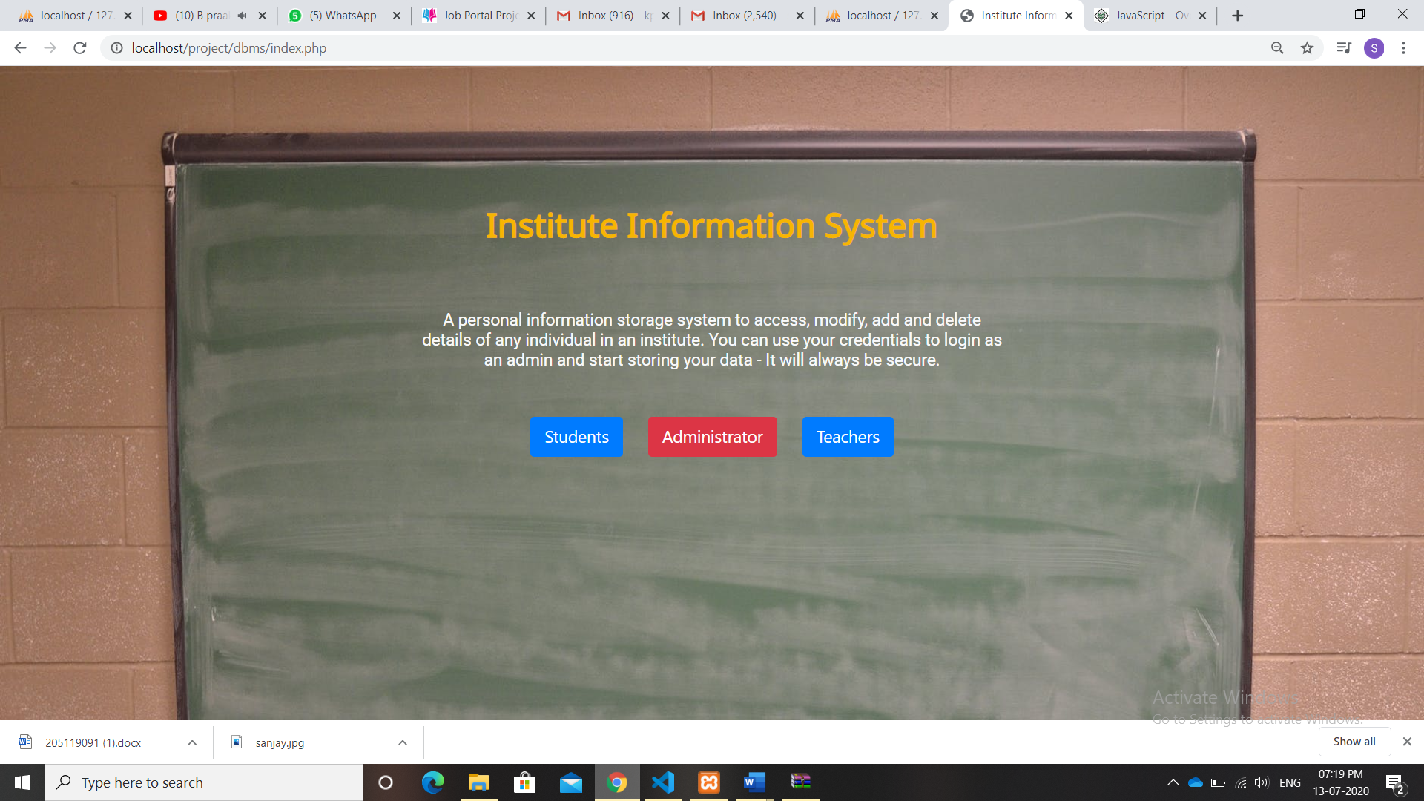

**STUDENT**

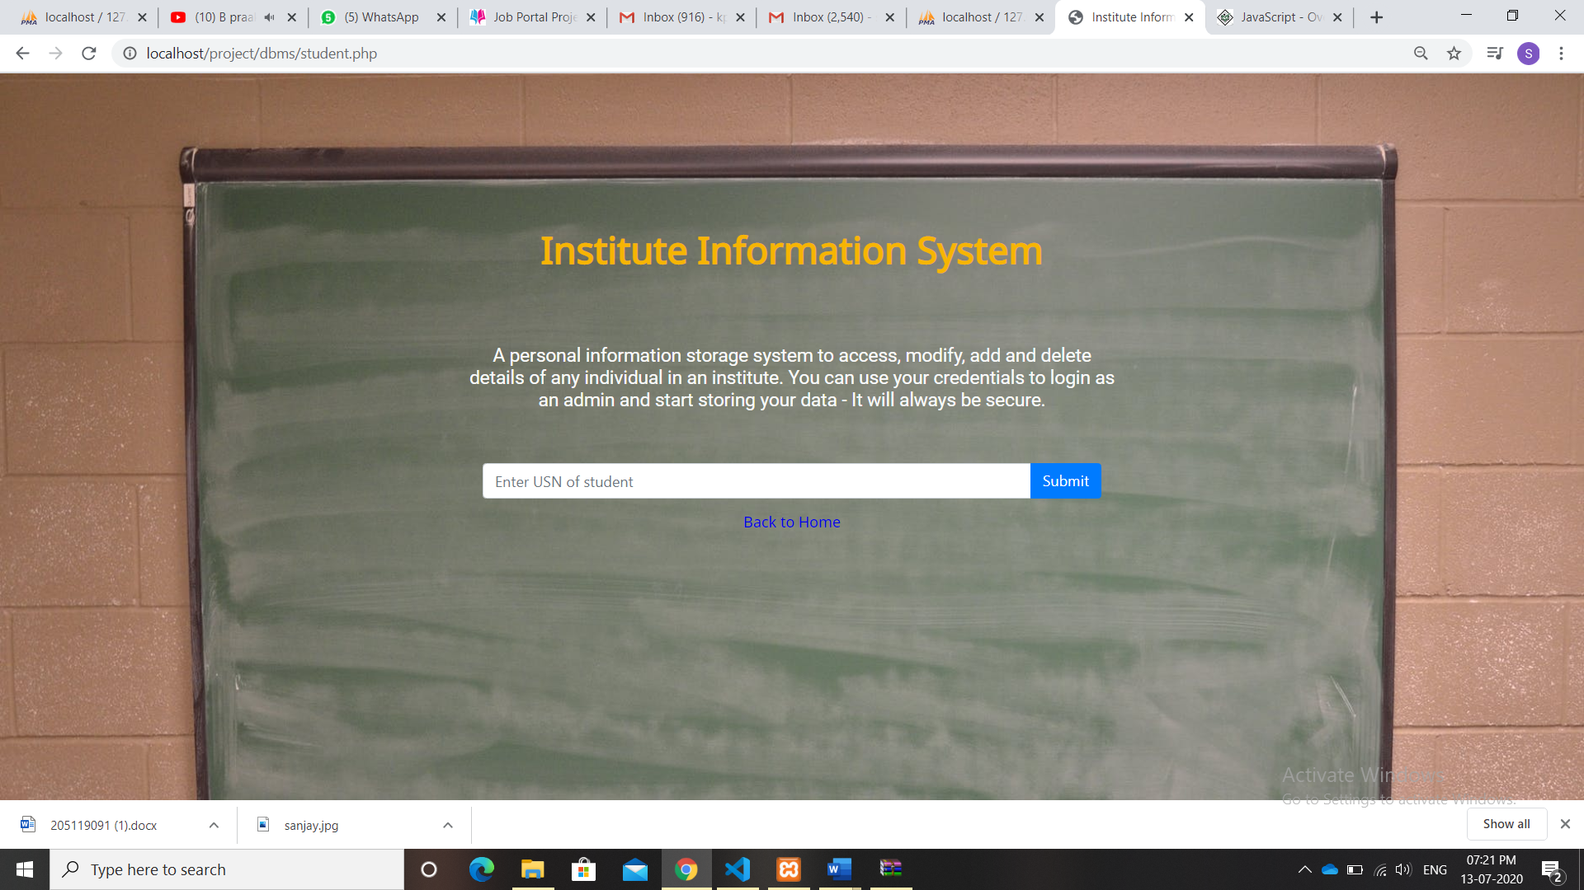

**TEACHER**

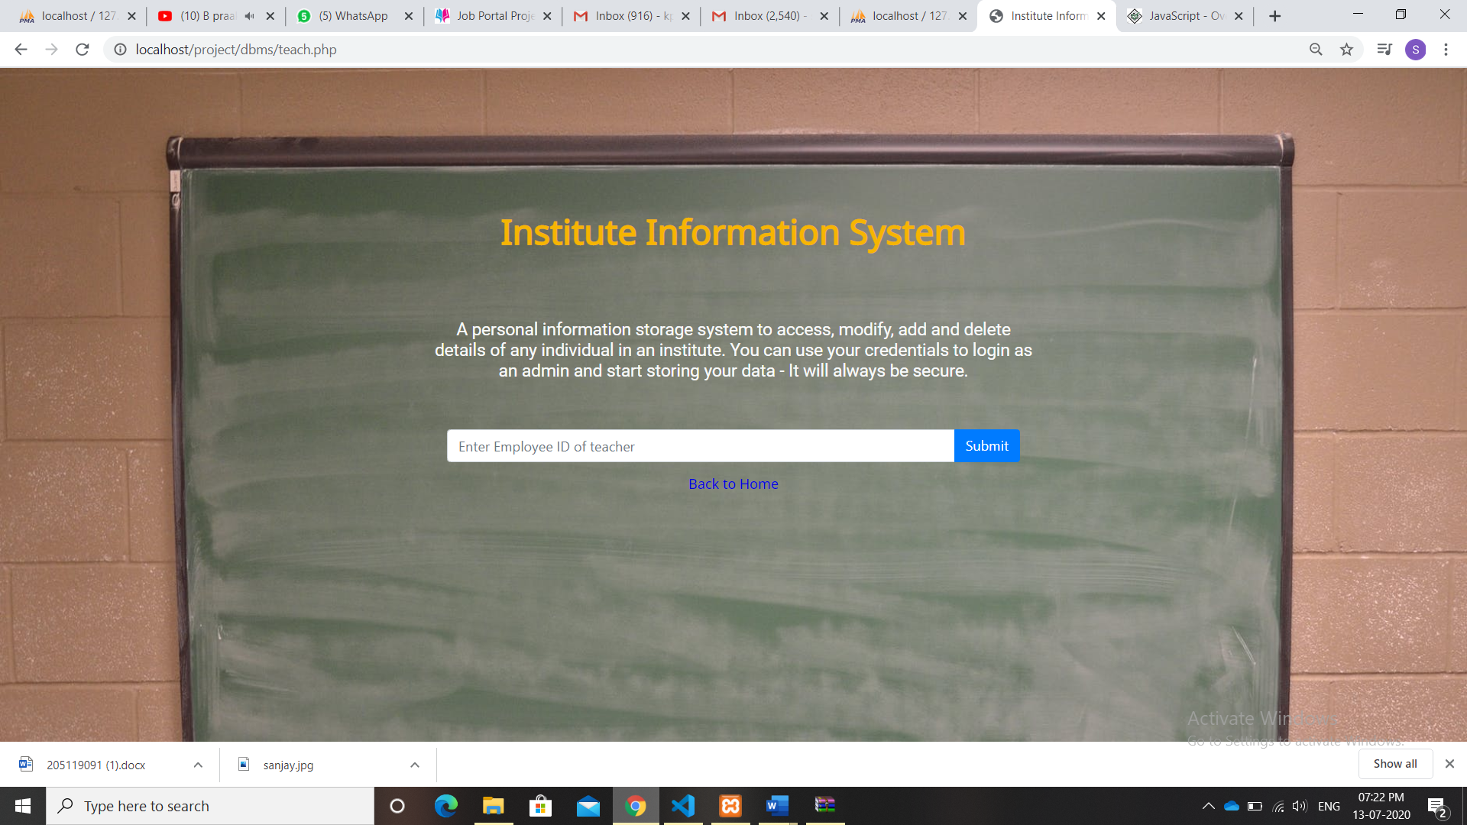

**LOGIN SECTION**

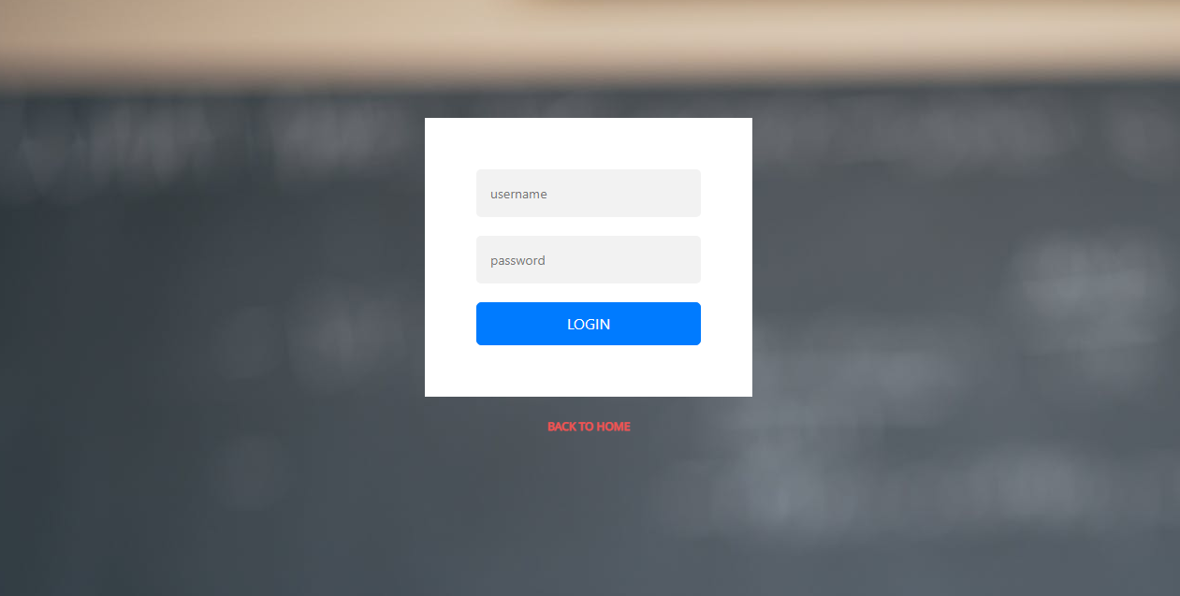

**ADMIN MENU**

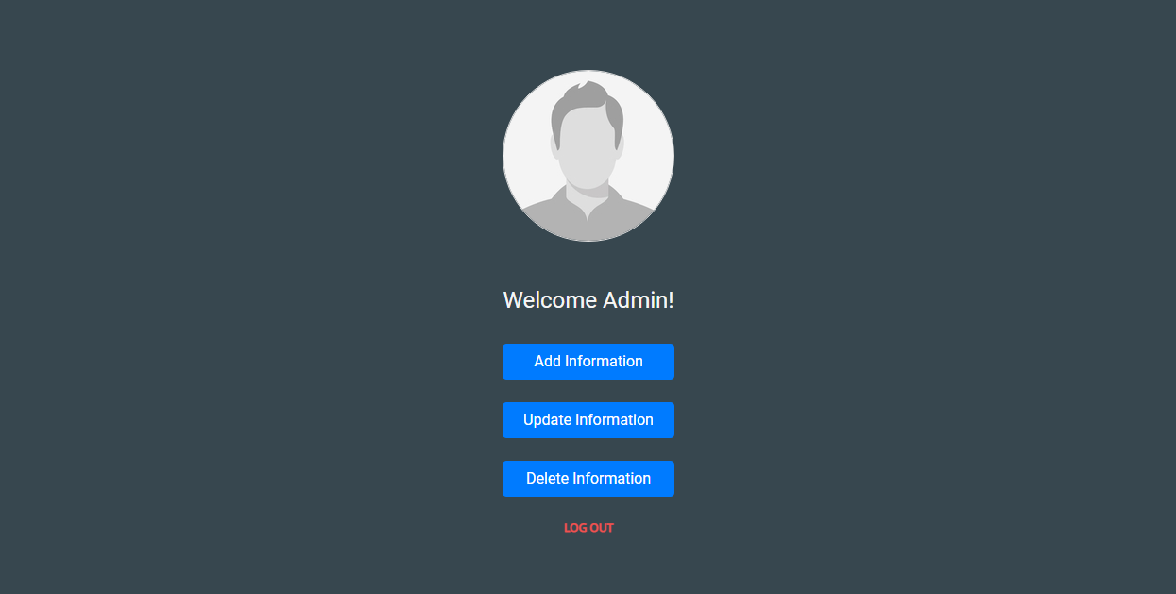

**ADD INFORMATION**

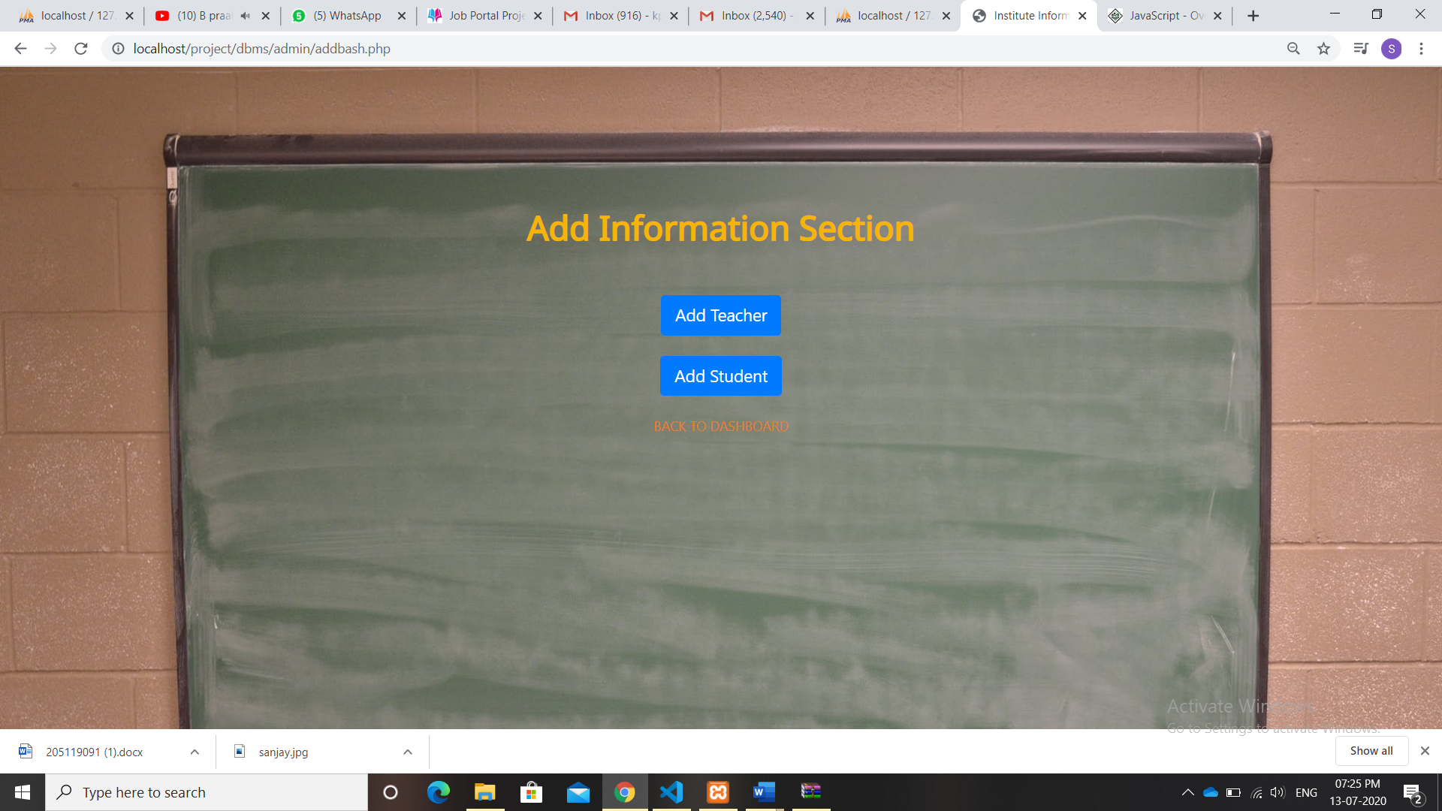

**TEACHER INFORMATION**

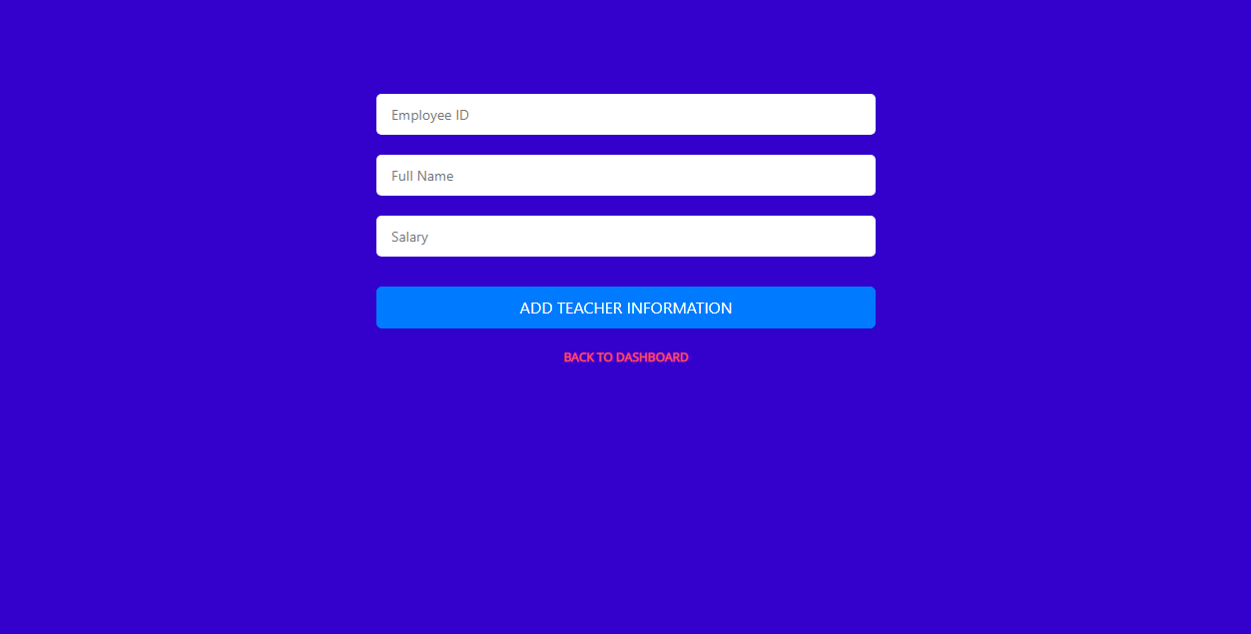

**STUDENT INFORMATION**

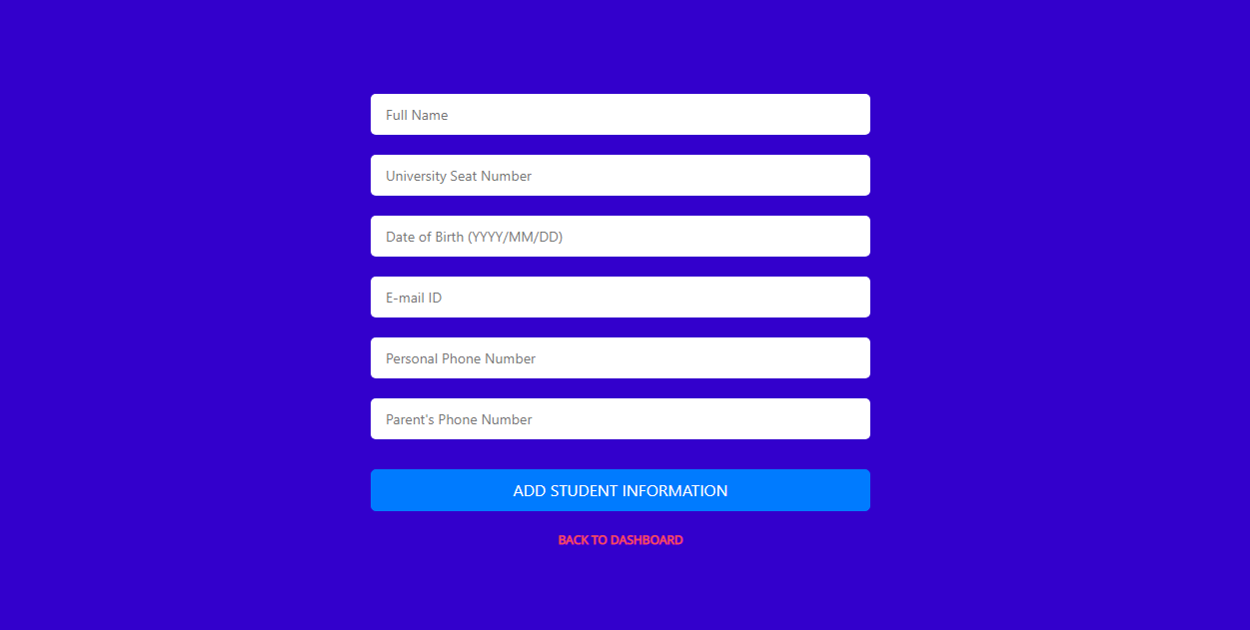

**UPDATE INFORMATION**

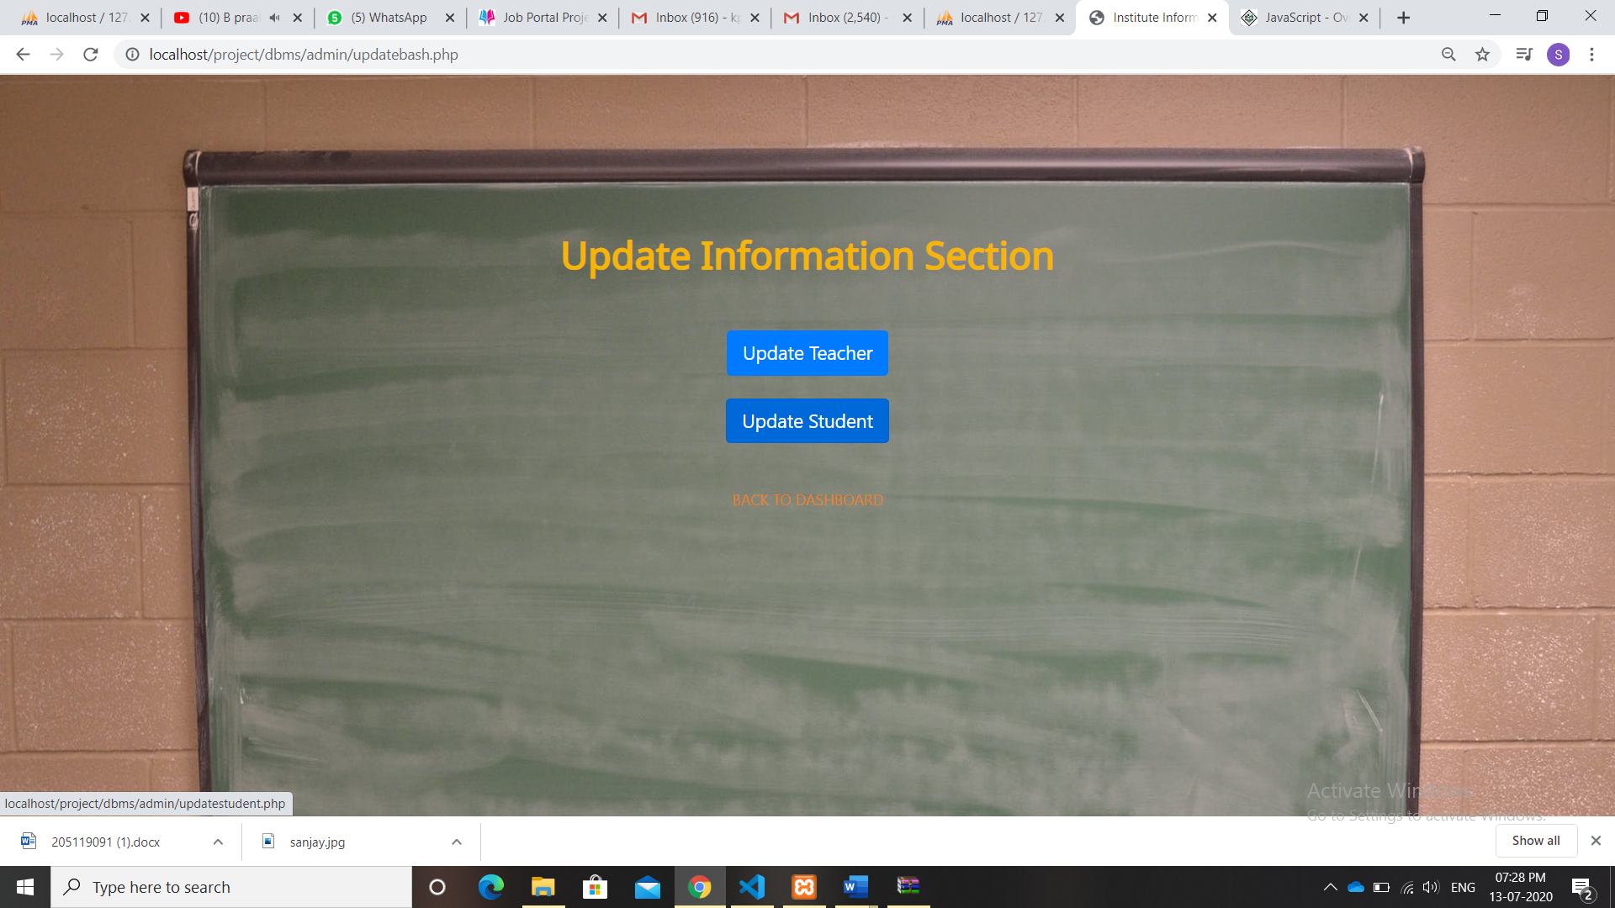

**DELETE INFORMATION**

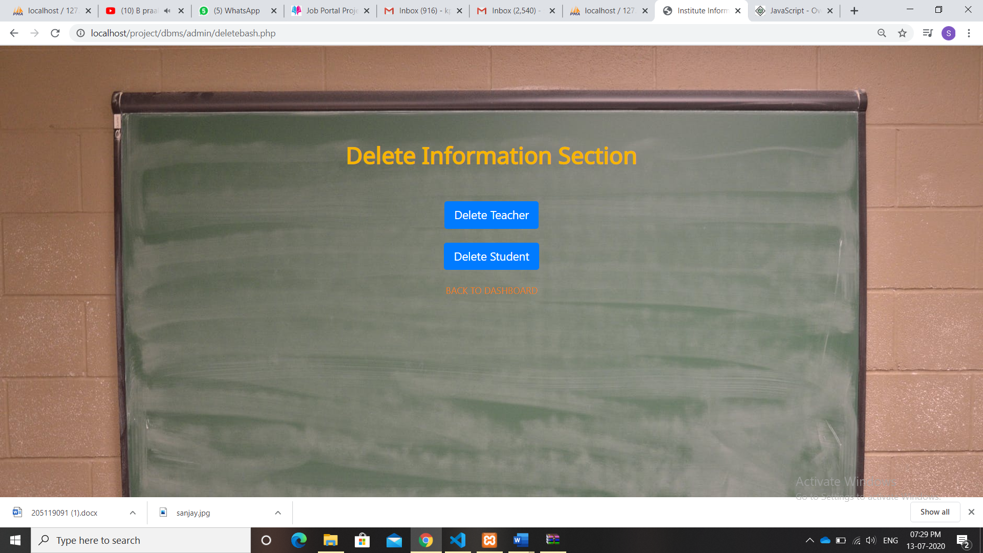

**6.DATABASE IMAGES**

**ADMIN**

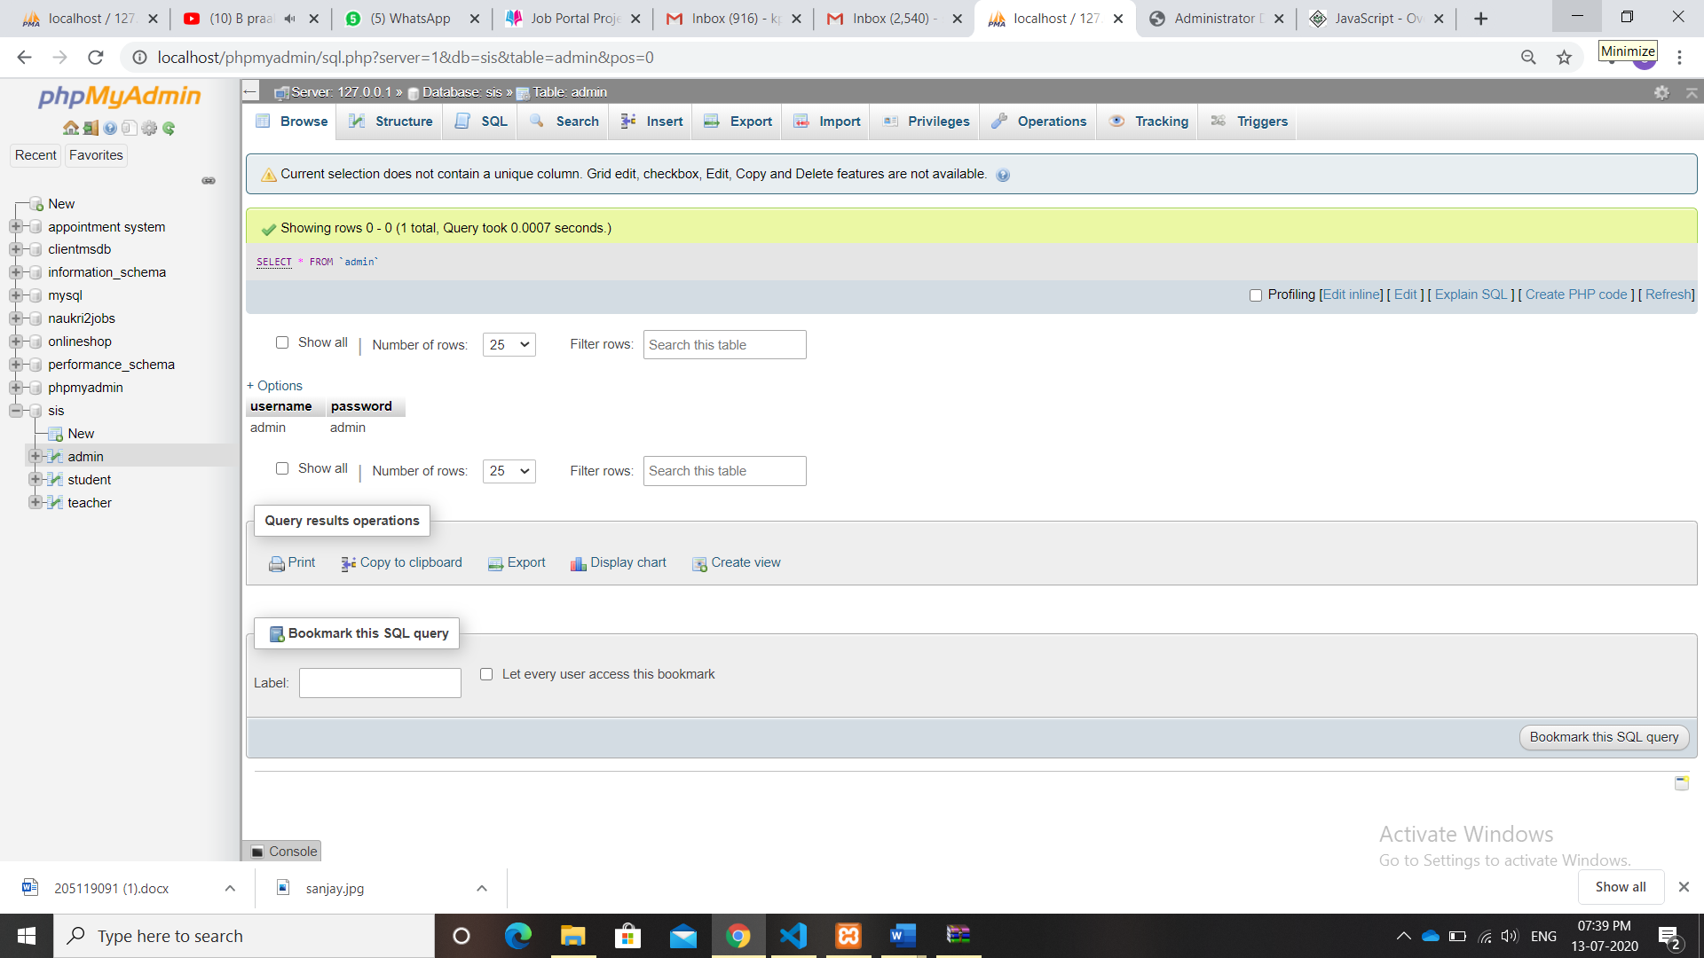

**STUDENT**

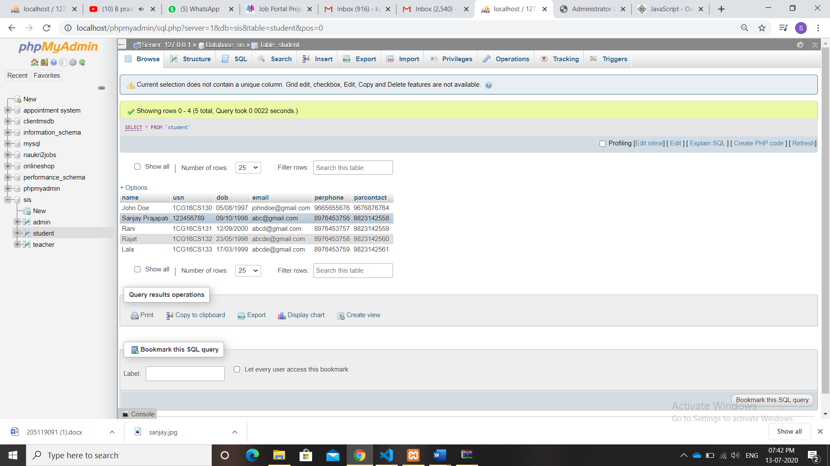

**TEACHER**

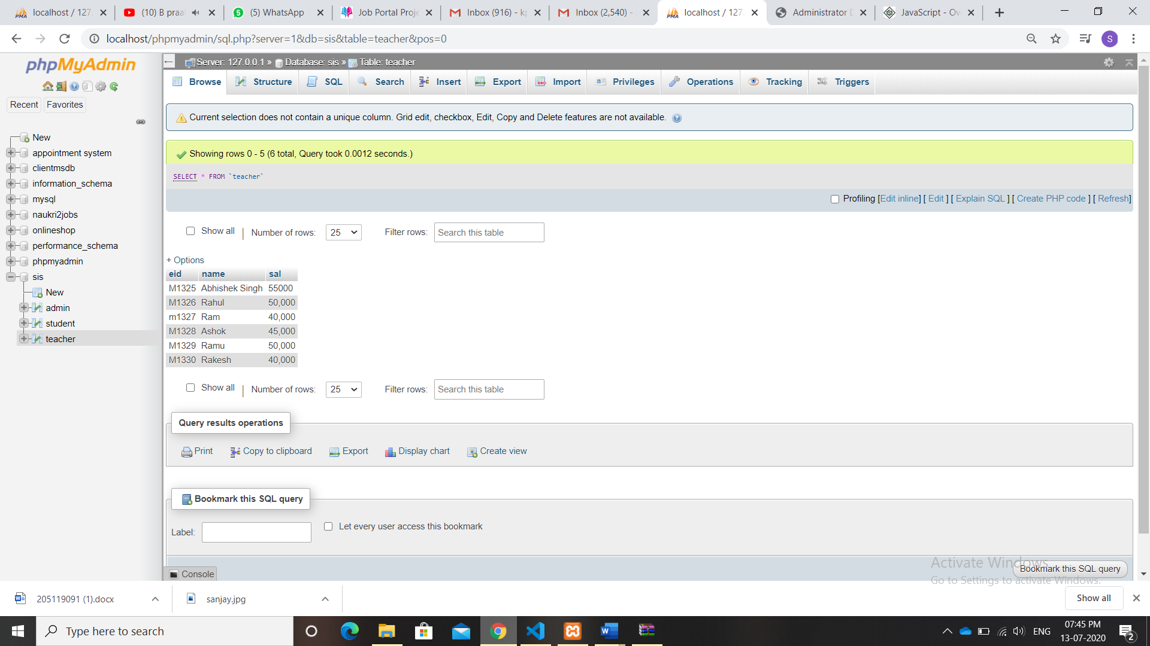

**7. CONCLUSION**

“It is concluded that the application works well. The application is tested very well and errors are properly debugged. The site is simultaneously accessed from more than one system. Simultaneous login from more than one place is tested. The site works according to the restrictions provided in their respective browsers. Further enhancements can be made to the application, so that the web site functions very interactive and useful to existing application”.